"Assam & Meghalaya – Wildlife, Waterfalls & Scenic Highlands”
(5N/6D)

Discover the beauty of Assam and Meghalaya on this unforgettable 6 Days / 5 Nights journey through Northeast India. Begin your adventure in Guwahati, home to the sacred Kamakhya Temple, before exploring the wildlife-rich Kaziranga National Park, famous for the endangered One-Horned Rhinoceros. Continue to the charming hill station of Shillong, known as the "Scotland of the East," and admire its serene lakes, waterfalls, and panoramic viewpoints.

Experience the natural wonders of Cherrapunji, renowned for its spectacular waterfalls, limestone caves, and mist-covered valleys. From thrilling wildlife encounters to scenic mountain landscapes and vibrant local culture, every destination offers a unique experience. Perfect for families, couples, honeymooners, and nature lovers, this itinerary promises an unforgettable journey through the enchanting landscapes of Northeast India.
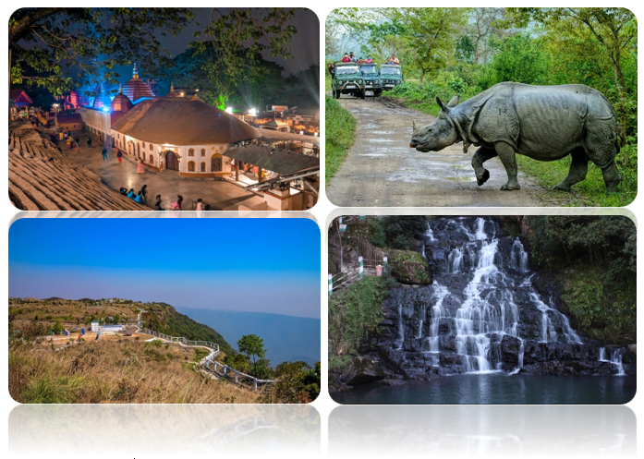

We wish you a happy, safe and unforgettable journey with us
Detailed Itinerary
Day 1: Arrive in Guwahati
Upon arrival at Lokpriya Gopinath Bordoloi International Airport or Guwahati Railway Station, meet our representative and transfer to your hotel. After check-in, visit the revered Kamakhya Temple, one of India's most important Shakti Peethas (subject to time). In the evening, enjoy a leisurely stroll along the Brahmaputra River or explore the local markets. Return to the hotel for an overnight stay in Guwahati.
Day 2: Guwahati – Kaziranga National Park
After breakfast, check out and drive to Kaziranga National Park, a UNESCO World Heritage Site renowned for its population of the One-Horned Rhinoceros. Upon arrival, check in to your resort and relax amidst the lush natural surroundings. In the afternoon, enjoy an exciting Jeep Safari through the national park (subject to availability and at an additional cost), where you may spot rhinos, elephants, wild buffaloes, deer, and a variety of bird species. Overnight stay in Kaziranga.
Day 3: Kaziranga – Shillong
Early in the morning, you may opt for an Elephant Safari (subject to availability and at an additional cost) for a unique wildlife experience. After breakfast, drive to Shillong, the picturesque capital of Meghalaya, known as the "Scotland of the East." En route, stop at the beautiful Umiam Lake, a perfect spot for photography and relaxation. Upon arrival, check in to your hotel and spend the evening at leisure exploring Police Bazaar. Overnight stay in Shillong.
Day 4: Shillong Sightseeing
After breakfast, enjoy a full-day sightseeing tour of Shillong. Visit the scenic Shillong Peak, offering panoramic views of the city, followed by Elephant Falls, one of Meghalaya's most famous waterfalls. Continue to Ward's Lake, Lady Hydari Park, and the Don Bosco Museum (subject to time). Return to the hotel in the evening for an overnight stay in Shillong.
Day 5: Shillong - Cherrapunji Excursion - Shillong
After breakfast, proceed for a full-day excursion to Cherrapunji (Sohra), famous for its dramatic landscapes, limestone caves, and breathtaking waterfalls. Visit popular attractions including Nohkalikai Falls, Seven Sisters Falls, Mawsmai Cave, Eco Park, and Arwah Cave (subject to time). Enjoy the spectacular views of lush valleys and mist-covered hills before returning to Shillong in the evening. Overnight stay in Shillong.
Day 6: Shillong – Guwahati Departure
After breakfast, check out from the hotel and drive back to Guwahati. If time permits, you may visit the Umananda Temple or enjoy some last-minute shopping before being transferred to Lokpriya Gopinath Bordoloi International Airport or Guwahati Railway Station for your onward journey. Depart with unforgettable memories of Assam's incredible wildlife and Meghalaya's breathtaking hills, waterfalls, and natural beauty.
Tour ends with unforgettable memories

HOTELS DETAILS:
Destination/Nights | 3* Hotel Name
Guwahati /01N
Kaziranga /01N
Shillong /03N

Package Cost:

3★ Hotels: Rs. per person (Based on 6 guests – Double Sharing Basis)

Inclusion: -
- Breakfast Included.
- 0 DBL Room on sharing based.
- 05 Nights in Accommodation in hotel.
- Assistance on Arrival.
- All Transfers and S.S tours by AC Vehicle.
Exclusions: -
- 5% GST.
- Flight Tickets are not included.
- Guide.
- Extra meal not included or as per the inclusions given above.
- No extra pickup or drop included for lunch/sightseeing unless otherwise mentioned in the itinerary.

